ONLINE APPLICATION GUIDE

Online Application
1. Open your Browser i.e. Mozilla Firefox, Google chrome, opera etc.
2. Type https://www.tum.ac.ke and press enter
3. Select E Register option then Public Access.

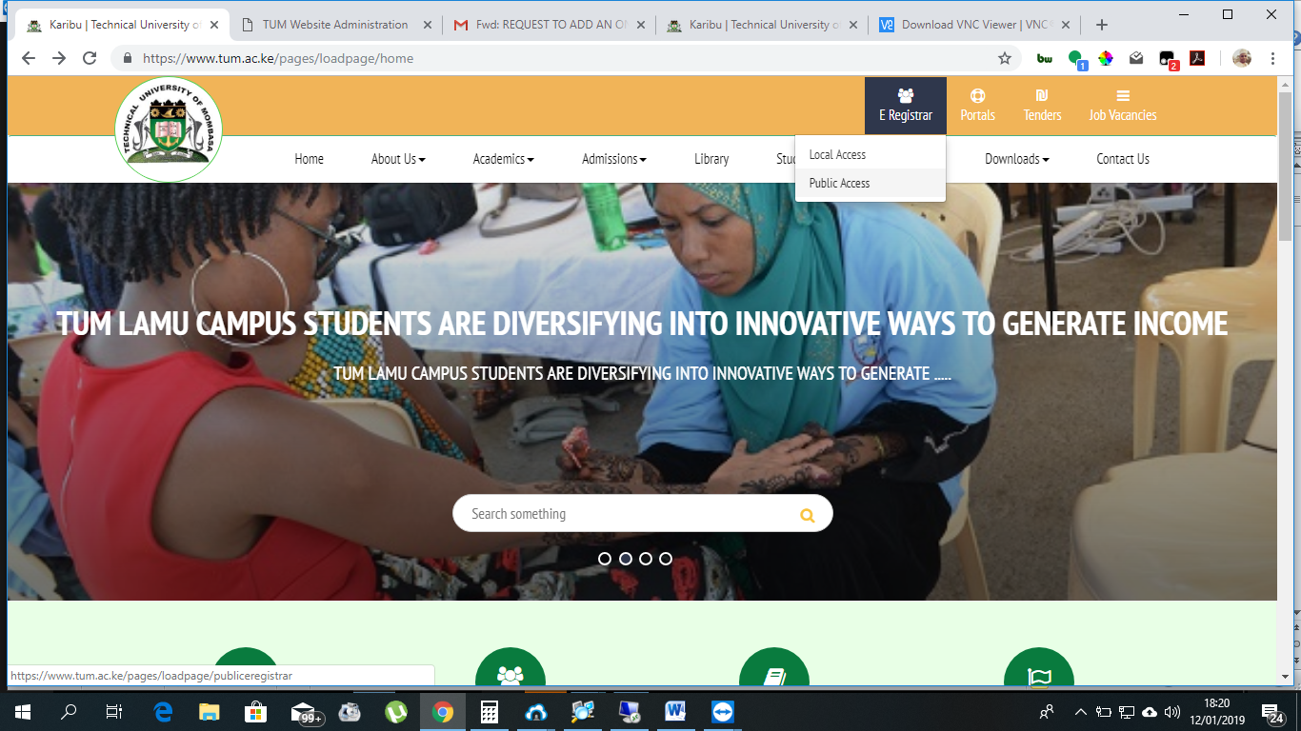

On the Displayed Screen.

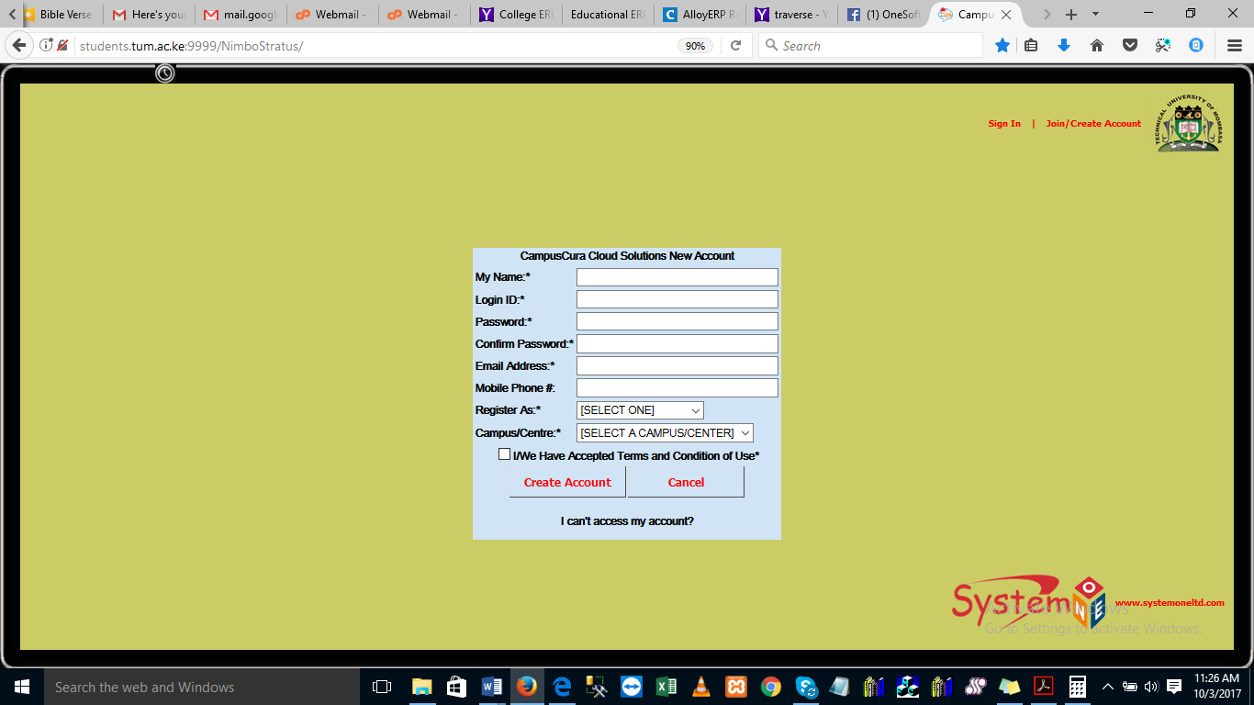

1. Capture your Name
2. Create for yourself Login ID and Password (i.e. your Names)
3. Type your Email Address, Mobile Phone Number.
4. Select your Registration type: as Course Applicant.
5. Select Campus you are applying to.
6. Accept terms and conditions then click on Create Account
- Click on My Programme Application.
- My Application Profile.

3. Capture your Personal Details, Academic Qualifications and Course Application.
NOTE: My Academic Referee and My CV is not mandatory.

